DeKalb County School District
Student & Parent Handbook
2015-2016

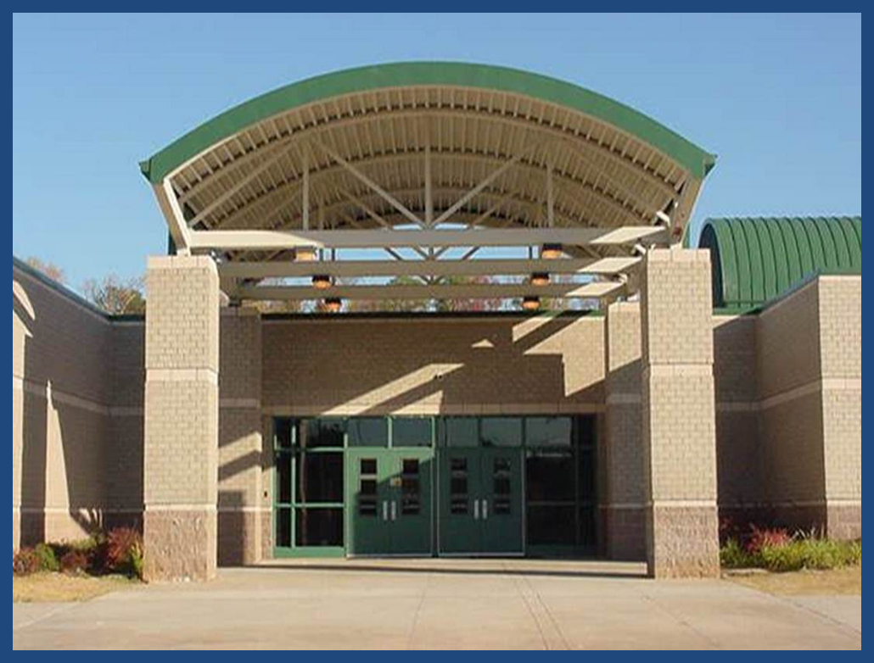

Cedar Grove Middle School
2300 Wildcat Road
Decatur, GA 30034


CEDAR GROVE MIDDLE SCHOOL

MISSION STATEMENT:

The mission of Cedar Grove Middle School is to prepare students for high school and productive citizens through performance-based instruction.

2300 Wildcat Road
Decatur, Georgia 30034
Office: (678) 874-4202
Fax: (678) 874-4210

ADMINISTRATIVE STAFF

Principal: Dr. Candace Y. Alexander

Assistant Principals: Dr. Shelton Bernard 6th Grade/
Instruction

Mr. Overton Wright 7th Grade/
Attendance

Ms. Patricia Wells 8th Grade/
Discipline

Counselors: Ms. Lanekia Pruitt 6th/8th/Grade Ms. Mary Crane 6th/7th Grade

SCHOOL TELEPHONE NUMBERS

MAIN OFFICE ……………………………………… 678-874-4202
COUNSELING OFFICE…………………………….. 678-874-4232
6TH GRADE OFFICE………………………………… 678-874-4221
7TH GRADE OFFICE………………………………… 678-874-4219
8TH GRADE OFFICE………………………………… 678-874-4220
CAFETERIA OFFICE…………………………………678-874-4236

Handbook Awareness

This handbook has been prepared for you so that you may become familiar with the regulations, policies, and opportunities at Cedar Grove Middle School. The information contained in this book will provide you with essential knowledge regarding attendance, discipline, student rights, responsibilities, and other aspects of school life. While it is not possible to cover every situation, this handbook should serve as a framework or tool that you can utilize to learn more about Cedar Grove Middle School.

DeKalb County School District

Vision: To inspire our community of learners to achieve educational excellence.

Mission: To ensure success, leading to higher education, work, and life-long learning.

Motto: Inspire-Achieve-Excel

Based on our core beliefs, we commit to the following:
- Focusing on teaching and learning
- Embedding an equitable and accessible 21st century learning environment supported by the use of emerging technologies throughout the curriculum
- Providing a safe and orderly learning & working environment
- Improving organizational effectiveness
- Maintaining fiscal responsibility
- Ensuring effective district & school leadership
- Ensuring that an effective teacher instructs every class
- Communicating to stakeholders in an open, honest, and accurate manner
- Embracing our community’s linguistic and cultural diversity & using it to enhance the educational environment through equity and access
- Creating an environment where everyone is valued and respected, encouraged to contribute, and recognized for his/her efforts
- Holding everyone accountable for educational excellence

School Information

Cedar Grove Middle School School Colors: Navy Blue & Columbia Blue

2300 Wildcat Road Nickname: Saints
Decatur, GA 30034

(678) 874-4202 FAX 678-874-4210

District Information

Superintendent
Dr. R. Stephen Green

Regional V Superintendent for Cedar Grove Middle
Dr. Ralph Simpson

DeKalb County School System Board of Education

Dr. Melvin Johnson, Board Chair, District 6

Mr. James L. McMahan, Vice Chair, District 4

Mr. Stan O. Jester, District 1

Mr. Marshall D. Orson, District 2

Mr. Michael A. Erwin, District 3

Mrs. Vickie B. Turner, District 5

Dr. Joyce A. Morley, District 7

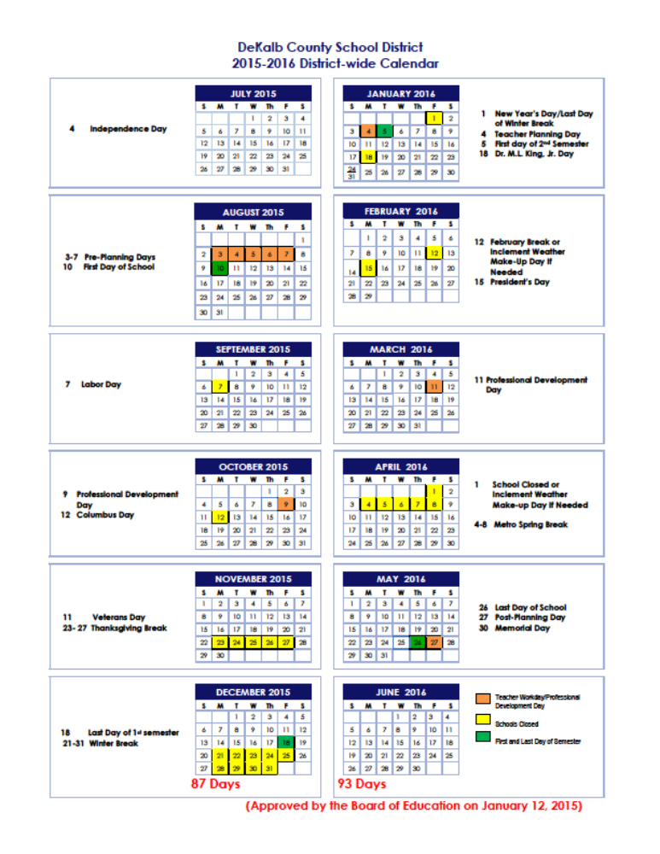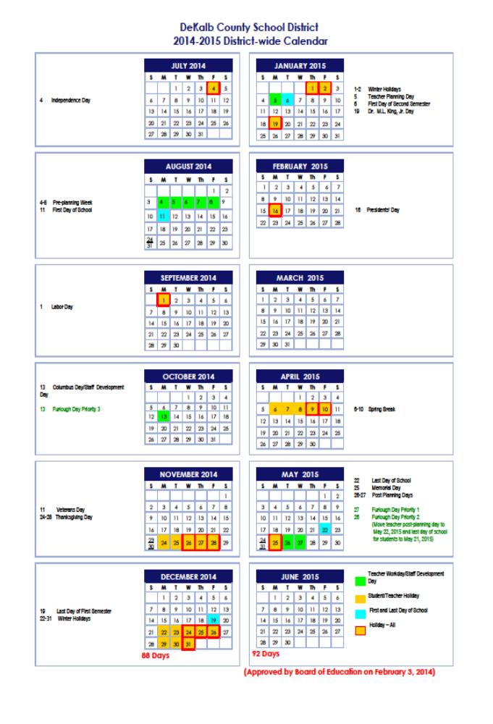

Middle School Testing Dates

Date | Test | Grade
Sept. 8 - 11, 2015 | Cognitive Abilities Test (CogAT) | Grade 7
Sept. 14- 25, 2015 | Iowa Tests of Basic Skills (ITBS) | Grades 7
Jan. 19 – Mar. 1, 2016 | ACCESS for English Language Learners (ELLs) | Grades 6 – 8
April 18 - April 29, 2016 | Georgia Milestones (EOG) | Grades 6 – 8
May 4 – May 11, 2016 | Georgia Milestones (EOC) (Carnegie Credit Courses) | Grade 8
May 4 – May 11, 2016 | Georgia Milestones (EOG) – Retest | Grade 8

Student Learning Objectives (SLO)
Students must participate in SLO Pre and Post Assessments for all courses where there is not a state required test Pre-Assessments must be administered within the first 10 days of a student entering a course and Post-Assessments must be administered at the end of each course and no later than May 20, 2016.

Universal Screener
Students must participate in SLO Pre and Post Assessment in grades k-9 are required to participate in the three main Universal Screener Windows. All schools have the capability and may administer the screener to all students to support instruction.

Universal Screener Assessment Dates
Aug. 10 – Sep 8, 2015 | District Screeng Window | Fall | Gradea 6-8
Jan. 5 – Feb 3, 2016 | District Screeng Window | Winter | Gradea 6-8
Apr. 25 – May 24, 2016 | District Screeng Window | Spring | Gradea 6-8
REQUIREMENTS:
High Academic Standards
Strict Conduct Code
Parental Involvement
Computer-based White Boards
Challenging Daily Homework
Semester Research Projects
Book Reports
Accelerated Reader Program
Parental Involvement

SPECIAL FEATURES:
Concentrated Instruction
Cross Curricular Instruction
Emphasis on Classic Literature
Spanish Instruction
Science Lab
S.T.E.M
Accelerated Reader
Computer Lab
Hands-On Activities

School Day & Supervision
The school day begins at 8:50 a.m. and ends at 3:50 p.m. Students may not be dropped off at school before 8:00 a.m. Unless students are participating in a special program or extra curricular activity, they must depart the campus immediately after school. If a student is left after school on a consistent basis, proof of residency will be requested and possible referral made to school social worker.
Report Cards and Grade Reports
Progress reports will be issued at four and half-week intervals. It is the student’s responsibility to give this report to their parent(s). In the event of an unsatisfactory progress report, parents are encouraged to meet with the teacher(s) to establish a plan of remediation to enhance the probability of success. Report cards are issued at the end of the first semester and the end of the school year.
Grading Scale
Excellent 100-90 = A
Good 89-80 = B
Fair 79-71 = C
Passing 70 = D
Below 69 = F

Parent-Teacher Conferences
Parent/guardian and teachers relationships are essential to student progress. Parent Teacher evening conferences are scheduled twice a semester. In addition, parents or teachers may initiate conferences at other times as necessary. At these conferences, the teacher and parent/guardian may review the child’s learning experiences and explore ways to improve them. We encourage feedback regarding instruction. Please check the school’s website for dates of these conferences.
Homework
Homework reinforces skills taught in the classroom, increases the student’s success on achievement tests, provide opportunities for parental involvement, and help to develop responsibility. Middle school students are expected to assume responsibility for their learning, which means working diligently on all assignments, including homework.
Makeup Work
It is the responsibility of the student to contact their teachers and obtain makeup work after returning from an excused absence. Parents of students absent for two or more days may contact the counseling department or the teachers for missed assignments. Make-Up work should be turned in within 5 days of the student’s return from an absence. All assignments not returned or incomplete will receive a grade of zero.
10
Lost Textbooks
Textbooks are the sole responsibility of the student. Students who lose textbooks must pay for the book prior to being issued another book with the same title. Report cards will not be issued to students with an outstanding balance for books.
Maintaining School Property
Students are expected to assist in maintaining cleanliness in the classroom, lunchroom, corridors, restrooms, and outside grounds and to exercise proper care in the use of school furniture and equipment. Students will be expected to make financial restitution for the deliberate damage of school property.

Teams
In a middle school, teachers are organized into teams, or groups of teachers who work together to plan instructional activities designed to provide life-long learning opportunities for our students. A team of teachers represents the following academic disciplines: Language Arts, Math, Science, and Social Studies.

Because your teachers are working together, they will get to know you better, and can communicate with each other and with you and your parents to help you achieve at the highest possible level.
Classes
Extended/Flexible Learning Time (ELT) provides middle school students with an additional period of academic instruction beyond the four traditional academic periods. The intent is to infuse literacy strategies into all content curriculums and to allow students to participate in engaging, interesting, and interactive activities. This course occurs daily and students will receive a grade for ELT courses each semester.

ELT will be followed by two of the core area classes (Science, Language Arts, Math and Social Studies) each day and either P.E. or a Connections class. Students may be assigned to one of the following Connections classes offered at nine-week intervals: Band, Spanish, Health, Computer Technology, Chorus
Music, Art, Physical Education, and
Math tools.

With the exception of a year-long course, students are not permitted to select their Connections classes.
After School Tutorial
Students in need of enrichment and remediation are provided with an opportunity to attend an after school tutorial program. Students are recommended for tutorial by their teachers.
Attendance Procedures
Georgia Law defines lawful absences as:
a) Illness; b) Death in the family; c) Religious Holiday; d) Instances in which attendance could be hazardous as determined by the DeKalb School; e) Service as a page in the legislature; f) subpoenas to court.

Irregular school attendance hinders student academic progress and decreases the satisfaction of full participation in school experiences. Georgia Law requires children between the ages of 6 and 16 to attend school. Students returning after an absence must present a written statement from the parent or guardian stating a reason for the absence.
Tardy Policy
The successful progress of your child in school depends on prompt and regular attendance. In addition to regular attendance, it is important for your child to be present for the full school day to receive the maximum benefits from instruction. Tardies are unexcused if the student does not bring a note.

Unexcused Tardiness to School/Class
1st - Warning
2nd - Warning and Parent Contact
3^{rd-} Parent Contact/Teacher Consequence
4th-5th - Referral to Administrator for Administrative Detention
6th – 9^{th -} ISS/Parent Conference/6 day letter
10th – ISS Pending local formal hearing.

Check Out
For your protection, the parents/guardians are required to proceed to the Front Office in order to check out a student. Only persons listed on the schools student information system as authorized contacts will be allowed to check out students. Driver’s License or pictured I.D. must be presented by the parent/guardian with authorized contact before a student is checked out. No student will be checked out after 3:45 p.m. for safety reasons. It is CGMS responsibility to ensure every child is safe during after school dismissal.
Leaving School without Permission
CGMS operates on a closed campus policy. Students are to remain on campus in the appropriate area from the time they arrive until school is dismissed unless granted permission by the Principal or an Assistant Principal. Students who leave without permission are subject to disciplinary action. Students who leave campus will forfeit their right to ride the bus and may be suspended. Students who walk home should not return to campus.

Visitors
CGMS extends a courteous welcome to all parents. Visitors are required to report to the front office to obtain authorization and a visitor’s pass. Under no circumstance will visitors be allowed to interrupt instructional time. Unauthorized persons found loitering on the campus or in the building will be asked to leave. Students from other schools may not visit Cedar Grove Middle School classes.
Medication
DeKalb County School employees may not provide or administer any medication to a student except as authorized by a parent or physician. All medications should be left with the Counselors Office Secretary. All medication must be in its original container. Students are not permitted to carry medication throughout the school day without the written permission of the principal.
Discipline
In order to provide a positive learning environment at CGMS, each student is expected to adhere to all the rules/regulations that are prescribed in the Student Discipline Brochure. Individual teams have the freedom to use a variety of strategies to discipline their students which may include but are not limited to loss of privileges, detention, phone calls to parents, etc.
Inappropriate behavior unbecoming of a student at Cedar Grove Middle School will be referred to the appropriate grade level administrator for disciplinary action. Students may be assigned administrative detention, In – School Suspension, or Out-of-School Suspension, based on the severity of the infraction. Students placed in an alternative setting (ISS, OSS), are not permitted any privileges that other students enjoy such as after school activities, sports, dances, etc.

Gang Related Activities
The staff of Cedar Grove Middle School, in conjunction with the DeKalb County and Decatur Police departments, is dedicated to preventing the influence and activities of gangs or groups acting as such at CGMS. We intend to prevent such influence and /or activities. For the purposes of our policy, a “gang” is defined as any group or association of 2 or more persons, whether formal or informal, which encourages, solicits, promotes, urges, counsels, furthers, advocates, condones, assists, causes, advises or abets any illegal or disruptive activity or behavior of any kind on school property or outside of school hours that adversely affects the educational process or endangers the health, safety, morals or well being of any student or employee of Cedar Grove Middle School.
No student shall:
- Display or wear gang articles, paraphernalia or clothing.
- Identify himself or herself as a member of a gang.
- Urge, encourage, promote, assist, cause, advise or abet any other student for purpose of gang related activity.
- Travel around in groups of 2 or more with the intent of intimidating another student or students.
* “STREET REPRESENTING AND NEIGHBORHOOD REPRESENTING” IN A NEGATIVE MANNER WILL BE TREATED AS A GANG RELATED ACTIVITY.

Conduct at Assemblies/Athletic Events
Students and student-athletes are expected to exhibit appropriate behavior at assemblies/athletic events (home and away). This includes no fighting, booing or heckling, throwing, etc. Any student in violation will be immediately removed from the setting and may face possible suspension.
Bullying / Harassment
State Law prohibits bullying. State law mandates a discipline hearing after the third incident of bullying with a referral to an alternative school upon a finding of guilt (O.C.G.A. 20-2-145).
Bullying/Harassment of any kind will not be tolerated. Students should report any experience of bullying/harassment to a teacher, counselor, administrator, and/or parents immediately. Any form of bullying (cyberbullying) using school equipment, school networks, e-mail systems or committed at school is strictly prohibited. *The Bullying Harassment Form for reporting bullying is located on page 73 of the Discipline Handbook.

Dress Code
The atmosphere of a school must be conducive to learning. A student’s appearance can positively or negatively impact the climate of a school. Students must adhere to DeKalb School System dress code requirements. Students, who fail to comply with the DeKalb School System dress code requirements, as enumerated below, may be charged with Offense #25 –Student Dress Code Violation (see page 28): Students are not allowed to wear ripped jeans. Ripped jeans with a patch purchased at point of sales is acceptable.

Students are expected to follow all school rules governing safety in specialized programs that may require the wearing of protective clothing, safety glasses, or other similar requirements.

Clothing or jewelry that disrupts the educational process or endangers the health or safety of other students, staff or visitors is prohibited. The wearing of clothing, insignia, symbols, or adornments worn or carried on or about a student which promote gangs, the use of controlled substances, drugs, alcohol, or tobacco is prohibited.

The wearing of clothing which shows offensive and/or vulgar words, pictures, diagrams, drawings, or includes words or phrases of a violent nature, a disruptive nature, a sexual nature, or words or phrases that are derogatory regarding a person’s ethnic background, color, race, national origin, religious belief, sexual orientation, or disability is prohibited. All shirttails must be tucked for all male students.

The wearing of pants below the waist line, bare midriffs, halter tops/tank tops, tops/blouses revealing cleavage, short shorts, net/see through garments, flip-flops, bedroom shoes, or other footwear that interferes with freedom of movement and dresses, pants, or skirts with high splits is prohibited. Clothes with holes, rips, slits, or tears are also prohibited.
15

Dress Code Violation (#25 DCSD Student Code of Conduct)
All students are expected to adhere to the expectations of appropriate dress as indicated in this handbook and any additional requirements listed in local school regulations. The following applies to all student dress code violations:
Number of Offenses | Actions of the School
First  Offense | Verbal Reprimand, Contact Parent and In-School Suspension (ISS) until End of Day or Correction of the Violation
Second Offense | Required Parent Conference and two (2) Days ISS
Third Offense | Contact Parent, three (3) Days ISS and Local Formal Hearing, which may result in up to ten (10) days ISS, Local Probation and/or parent attend classes with student in lieu of ISS. Chronic violation of this expectation will result in the charge of #19a (Student Code of Conduct) – Repeated Violation of School Rules and a possible referral to an alternative setting upon a finding of guilty by the Student Evidentiary Hearing.  154

The dress code policy will be strictly enforced. School administrators have the authority to make the final decision on appropriate dress concerns.

New Uniform Policy
Your child is in violation of Cedar Grove Middle School's uniform policy by not wearing the following:

Blue, Yellow, and/or White Tops: Polo/collared shirts and blouses (long or short sleeves) with the school's logo. Cardigans sweater vests for cool weather may be black or yellow with the school's logo.

Black/Khaki Bottoms:
Females
Slacks/pants (khaki or black)
Skirts – knee length (khaki or black)
For belt loops (black or brown)
Bottoms should fit property
Males
Trousers/pants (khaki or black)
Shorts- knee length (khaki or black)
Belts are required for belt loops (black or brown)
Shoes
Black or Brown Shoes – no sandals or boots. All must be safe and appropriate for the learning environment. Students may not wear athletic, low heeled or flat shoes. Student must wear athletic shoes in all Physical Education classes and/or outdoor activities. Sandals, slippers, flip flops, open toe shoes, thong sandals, stilettos and the like are not permitted to be worn on campus.
Jackets
Jackets and winter coats must be in school color.

Students out of uniform will be stopped at the bus lane and a parent will be contacted from a designated room. Parents will be asked to bring a uniform to school. The student will be in the ISS room until the violation is corrected. Students in violation will be charged Refusal to Follow Directions (8B) from the Student Code of Conduct. These charges will be reflected on the discipline record. Parents may purchase a uniform from the school store in the morning, during lunch, and immediately after school.

Restrooms
Restrooms should not be used between classes. Go directly to class and speak with your teacher regarding a hall pass and signing the MOBILITY LOG for accountability.
Lockers
Students are permitted to use lockers only during the designated locker time. Failure to respect locker rules shall result in the loss of your locker, for a specified period of time. Homeroom teachers will assign lockers. All lockers have built-in combination locks. Sharing lockers is not permitted. You are responsible for the contents of the locker that is assigned to you.
Book Bags
All book bags must be kept in the lockers during the school day. Book bags are not permitted during the final three days of the school year.
Local School Probation Contracts
When students engage in disruptive confrontational behavior, a counselor, in the mediation process may require the students involved to sign a contract. This contract is the student’s agreement that they will cease from having any verbal or physical contact with the students involving the issue that caused the conflict. Failure to follow the contract and any future confrontations will result in additional disciplinary consequences. Fighting will not be tolerated at CGMS and will result in out of school suspension. Repeated occurrences may result in the calling of a disciplinary hearing.

Prohibited Items
The following items are prohibited at all times: Radios, CD players, Electronic games, MP3’s, IPODS, PSP players, Toys, Stuffed animals, Cameras, Comic books, Yo-Yo’s, Mouth Grills, Playing cards, Wallets with chains, Dice, Chains attached to jeans or wallets, and Laser pointers. These items will be confiscated and only returned to the parent/guardian.

Transportation
Students who ride to school in automobiles are to be dropped off and picked up at the front entrance. If a student needs to ride home on a different bus other than the one he or she usually rides on, a note from the parent must be presented to the grade level administrator’s office prior to the beginning of first period; the grade level secretary will verify these notes. This applies also to a car rider riding home on a bus. If the note cannot be verified in advance, the student will not be allowed to ride on that bus.

Telephones
Telephones at CGMS are for business use only. They should be used only in case of an emergency such as an accident or illness. A secretary must give you permission to use the phone. If you are unable to locate a parent or guardian, you may leave a message for him or her from a school phone.

Use of
Electronic Communication Devices
Radios, CD/tape players, MP3's, I-Pods, pagers, games, etc. of any kind are banned from school during the regular school day. IF AN ELECTRONIC COMMUNICATION DEVICE IS STOLEN OR MISPLACED, CGMS RESERVES THE RIGHT TO COMMENCE AN INVESTIGATION.

A student may possess a cellular telephone or other electronic communication device (ECD) in school, on school property, during after school activities and at school-related
functions. However, when students enter the building, the ECD must be powered OFF completely and headphones disconnected and put away.

Cell Phones
- Place in locker before 8:50 am during 1st locker break.
- Retrieve from locker after 3:40 pm during final locker break.

Students found in violation of the electronic communication devices policy will have the item confiscated and item must be picked up by a parent/guardian on Thursdays from 4:45 pm to 5:30 pm. In addition, students will be charged with Electronic Communication Devices (1) and Refusal to Follow Directions (8B) from the Student Code of Contact. These charges will be reflected on the discipline record. The following acts will not be tolerated:
- Electronic communication devices must be completely off in the halls, cafeteria, and classrooms and in the gym and locker rooms.
- Electronic communication devices must be concealed at all times and NOT visible. Headphones cannot be connected to the electronic device nor can they hang out of the clothing. Headphones must be put away completely
The use of cell phones and other electronic communication devices in the locker rooms and rest rooms is prohibited. The taking or sharing of obscene pictures or videotaping any altercations is a punishable offense. ECD's capable of wireless and unfiltered connections to the Internet are prohibited. Students found to be using any electronic communications device in violation of these rules, or for any illegal purpose, shall be subject to disciplinary action under the Student Code of Conduct.

Monitoring Cameras
The school board authorized the purchase and installation of internal and external video monitoring equipment on school grounds as part of a multifaceted approach to protecting the safety and security of students, staff, and property.

The district recognizes it must balance the rights of privacy of students and staff with its duty to provide a safe site for learning and to safeguard district facilities and equipment. Video monitoring shall be used only to promote the order, safety, and security of students, staff, and property.

Staff and students are prohibited from unauthorized use, tampering with or otherwise interfering with video camera equipment and will be subject to appropriate disciplinary action.

Property
Actual, Attempted or Threatened Destruction/Damage/Vandalism/Arson to School, Public or Private Property.
Students will not attempt or threaten to destroy, damage, vandalize, or deface, or set fire to school, public or private property located at the school. NOTE: The student must make restitution for any damage to school or personal property caused by his/her behavior while on school property. A required 10-day suspension must be served and a due process hearing held for Level 6-7 this include damage, vandalize or defacing the Bathroom Stalls. Students must make restitution for any damage caused by the student’s behavior. Any form of electronic bullying (cyberbullying/cyberstalking), threats and/or harassment using school equipment, school networks, e-mail systems or committed at school is strictly prohibited. (See page 18 of the Code of Student Conduct Handbook.)

Clubs
CGMS offers its students many opportunities to become involved in activities outside of the classroom. We offer clubs that appeal to a wide variety of student needs and interests.

Athletics and Extracurricular Activities
The athletic program at CGMS involves 7th/8th grade boys and girls. If you are entering 8th grade and passed at least 6 out of 7 courses during the previous semester of school and you have an approved physical on file, you are eligible to participate. Cheerleading, Football, Basketball, and Track are open to 7th and 8th grade students only.
Cheerleading and Dance tryouts are held the previous year in the spring for football season.

*If a student is absent during a school day, they may not participate in extra-curricular activities for that day. You must be present for at least three periods to be considered present for the day.
School Deliveries
Delivery of balloons and flowers will not be permitted. The deliveries of these items create a disruption to the school day.
Media Center

The students at CGMS are encouraged to visit the Media Center to complete required class assignments, check out books and browse through magazines.

Emergency Information
Accidents: In case of any accident on the school grounds, the teacher in charge, the principal, or the assistant principal should be notified immediately.

Fire: Fire drills will be conducted monthly to prepare students and staff for orderly evacuation of the building in case of fire. You will remain in a straight line well away from the building and attendance will be taken. No one will be allowed to return to the building for any reason until notified that it is safe.

Tornado
In case of a tornado warning, you will go quietly to the area your class is assigned to and sit on the floor. Coats, jackets or books can be used to cover heads, arms and legs to reduce injuries from flying glass and other objects. You are expected to remain quiet at all times and to follow the directions of your teacher.
Insurance
School insurance is available at the beginning of the school year for a reasonable fee. Both school day coverage and 24-hour coverage are available. If you have school day only coverage, you will not be covered for the after-school sports activities or for overnight field trips. Contact the main office for information regarding purchasing school insurance company, coverage and file claims.

Release of Directory Information
The District may disclose appropriately designated “directory information” without written consent unless the parent, guardian, or eligible student as advised the District to the contrary in accordance with District procedures. (See page 49 of the Code of Student Conduct handbook.)

School Closings
In case of snow, ice or other severe weather, the official stations for school closing information are WSB-AM radio (750) and WSB-TV (Ch. 2). Students and parents should listen to those stations rather than calling the school or the Board of Education offices.

Physical Education
Physical Education is an integral part of the instructional program. All students receive physical education class daily. All children will be required to participate unless a doctor’s statement is presented. If, on a particular day, your child cannot participate, please send a signed note to your child’s homeroom teacher. A daily note will be satisfactory for up to three (3) consecutive days. After that time, a doctor’s statement will be required to excuse your child from physical education activities. Students are required to dress out in approved attire appropriate for physical activity. For the safety of your child, closed toe shoes are required during Physical Education. Sandals, clogs, and/or flip-flops are not acceptable footwear.

Substitute Teachers
When a teacher is absent in one of your child’s classes, our school will provide a responsible teacher to continue the program of instruction. All substitute teachers are fully qualified and are on the DeKalb County School System’s approved list.

Home Addresses, Phone Numbers, and Emergency Contacts
It is the responsibility of all parents and guardians to keep the school informed and updated on any changes in home address, home telephone numbers, and work telephone numbers.

Immunization
Georgia law stipulates that no student shall be admitted to or attend any school or facility in this state unless such student shall first have submitted a certificate of immunization.

Comments, Questions, or Concerns, Please Contact Us:
www.Twitter.com @CGMSaints
www.instagram.com @CGMSaints
www.remind.com @CGMSaints
www.facebook.com @Cedar Grove Middle


Parent Assistant
The Parent Assistant page is your launching point for reviewing your child’s academic progress and attendance history. The link below will allow you to register for Parent Access, go to the logon page, and view tutorials anddocumentation: http://eportal.dekalb.k12.ga.us.

Textbook Online Access Codes

Carnegie Learning Math Series – Grade 8 (Cost: $17). Students are able to access their textbooks, assignments, and skills practice worksheets using http://resources.carnegielearning.com (See you math teacher for code.)

Registration for ELA Online Textbook at Classzone
- Go to classzone.com (http://www.classzone.com)
- Select Language Arts…Middle School…Select
- state…click GO
- Select McDougal Littell Literature (Grade 6, 7, or 8)
- Select Online book
- Click Continue
- Select Create a Student Account
- Enter Activation Code and then Click continue
Grade 6: 5671648-50
Grade 7: 5671648-70
Grade 8: 5671648-90
Enter MCDKLMLHLPIHU for Teacher Access Code and then complete information on the page and click Create Account.

Georgia Science Grade 8 – (Cost: $67.75). Students are able to access their textbooks, assignments, and skills practice worksheets for free using this site: http://Glencoe.mheducation.com/sites/0078778468/student_view0/online_student_edition.html.

- Once students have accessed the site, click on online student edition under textbook resources.
- Click under Gerogia Sceince Grade 8 in middle of the page.
- New window or tab will open. Enter code (see teacher for code).
- Book will open after entering code.

Access code only works on Internet Explorer (see teacher for details).

INDEX

Administrative Staff 3
After School Tutorial 11
Athletics & Extracurricular Activities 18
Attendance Procedures 11
Book Bags 15
Bullying/Harassment 13
Cedar Grove Mission Statement 2
Check Out 12
Classes 11
Clubs 18
Conduct at Assemblies/Games 13
DeKalb County School District 4
Discipline 12
District Calendar 7
Dress Code 13
Electronic Communication Devices 16
Emergency Contacts 19
Emergency Information 18
Gang Related Activities 13
Homework 10
Immunization 19
Insurance 18
Leaving School Without Permission 12
Local School Probation Contracts 16
Lockers 15
Lost Textbooks 10
Maintaining School Property 10

Makeup Work 10
Media Center 18
Media Release Form 7
Medication 12
Middle School Testing Dates 9
Monitoring Cameras 17
Parent Assistant 19
Parent-Teacher Conferences 10
Physical Education 19
Progress & Grade Reporting Dates 8
Prohibited Items 16
Property 17
Release of Directory Information 19
Report Cards & Grade Reports 10
Restrooms 15
School Closings 19
School Day & Supervision 10
School Deliveries 18
School Information 5
Social Media Contacts 19
Substitute Teachers 19
Tardy Policy 11
Teams 11
Telephones 16
Textbook Online Access Codes 20
Transportation 16
Visitors 12



School Level Parental Involvement Policy



PART I: GENERAL EXPECTATIONS

2015 - 2016 School Parental Involvement Policy
Revised: October 2015

Cedar Grove Middle School 518

In support of strengthening student academic achievement, each school that receives Title I, Part A funds must develop jointly with, agree on with, and distribute to, parents of participating children a written parental involvement policy, agreed on by such parents, that contains information required by section 1118 (b)(1) of the Elementary and Secondary Education Act of 1965 (ESEA) (school parental involvement policy). The policy establishes the school’s expectations for parental involvement and describes how the school will implement a number of specific parental involvement activities, and it is incorporated into the school’s plan submitted to the local educational agency (LEA).

The school will adhere to the following as required by law:

- Involve parents, in an organized, ongoing, and timely way, in the planning, review, and improvement of programs under Title I, Part A, including the planning, review, and improvement of the school parental involvement policy and the joint development of the schoolwide program plan under section 1114(b)(2) of the Elementary and Secondary Education Act of 1965 (ESEA).
- Update the school parent involvement policy periodically to meet the changing needs of parents and the school and distribute it to the parents of participating children and make the parental involvement plan available to the local community.
- Provide full opportunities, to the extent practicable, for the participation of parents with limited English proficiency, parents with disabilities, and parents of migratory children, including providing information and school reports required under section 1111 of the ESEA in an understandable and uniform format and including alternative formats upon request, and, to the extent practicable, in a language parents understand.
- If the schoolwide program plan under section 1114 (b)(2) of the ESEA is not satisfactory to the parents of participating children, submit any parent comments on the plan when the school makes the plan available to the local educational agency.
- Be governed by the following statutory definition of parental involvement and will carry out programs, activities, and procedures in accordance with this definition:

Parental involvement means the participation of parents in regular, two-way, and meaningful communication involving student academic learning and other school activities, including ensuring –

- that parents play an integral role in assisting their child’s learning;
- that parents are encouraged to be actively involved in their child’s education at school;
- that parents are full partners in their child’s education and are included, as appropriate, in decision-making and on advisory committees to assist in the education of their child;
- carrying out of other activities, such as those described in section 1118 of the ESEA.

PART II. DESCRIPTION OF HOW THE SCHOOL WILL IMPLEMENT REQUIRED SCHOOLWIDE PARENTAL INVOLVEMENT POLICY COMPONENTS

The School Level Parental Involvement Policy must include a description of how the school will implement or accomplish each of the following components. [Section 1118(b)(1), ESEA]. This is a sample template, as there is no required format for these descriptions. However, regardless of the format the school chooses to use, a description of each of the following components below must be included in order to satisfy statutory requirements.

Parental involvement is a combination of commitment and active participation on the part of the parent to the school and to the student. There are many challenges concerned with parental involvement; however, the main benefit of parental involvement is the improved achievement of the student.
As a major effort of establishing a sound and collaborative parent and school relationship, Cedar Grove Middle School will conduct its Annual Title I Night on August 27, 2015. This activity is planned to afford parents to learn about the many instructional goals of the school and provide the many opportunities for parents to become and remain dedicated and responsible participants in their child's education during the middle school years.

- The Cedar Grove Middle School will take the following actions to involve parents in an organized, ongoing, and timely manner in the planning, review, and improvement of Title I programs including involvement in the decisions regarding how funds for parental involvement will be used.

- The Cedar Grove Middle School will take the following actions to conduct an annual meeting, at a convenient time, and encourage and invite all parents of participating children to attend, to inform them about the school’s Title I program, the nature of the Title I program, the parents’ requirements and the school parental involvement policy, the school wide plan, and the school-parent compact.

The Annual Title I Meeting was held Thursday, August 27, 2015. Parents were informed by School Website, Two and One Week Notices, School-wide Calling Post, and School Marquee.

- The Cedar Grove Middle School will take the following actions to offer a flexible number of meetings, such as meetings in the morning or evening, and may provide with Title I funds, transportation, child care or home visits, as such services relate to parental involvement.

Cedar Grove Middle School provides an on-site Parent Liaison in our Parent Outreach Center Located in Room 105. This center is an information hub for all Community Stakeholders. Parents are encouraged to visit the centers and make use of the resources that have been made available specifically for parents to help their children achieve. Information and resources are available for parents of students who are performing at all levels, from high achievers and gifted, to regular education and special needs.

- The Cedar Grove Middle School will take the following actions to provide parents of participating children the following:
  - Timely information about the Title I programs;
  - Description and explanation of the curriculum in use at the school, the forms of academic assessments used to measure student progress, and the proficiency levels students are expected to meet;
  - Opportunities for regular meetings, if requested by parents, to formulate suggestions and to participate, as appropriate, in decisions relating to the education of their child, and respond to any such suggestions as soon as practicably possible;

- The Cedar Grove Middle School will take the following actions to jointly develop with parents of participating children a school-parent compact that outlines how parents, the entire school staff, and students will share the responsibility for improved student academic achievement, and the means by which the school and parents will build and develop a partnership to help children achieve the State’s high standards.

Monthly Document Review September / October
PTSA Meeting
September 2015
October 2015
November 2015
December 2015
January 2016
February 2016

Parent Conference Night

- The Cedar Grove Middle School will build the school’s and parents’ capacity for strong parental involvement, in order to ensure effective involvement of parents and to support a partnership among the school involved, parents, and the community to improve student academic achievement, through the following activities specifically described below:

- The Cedar Grove Middle School will provide assistance to parents of participating children, as appropriate, in understanding topics such as the following, by undertaking the actions described in this paragraph –
  - the State’s academic content standards;
  - the State’s student academic achievement standards;
  - the State and local academic assessments including alternate assessments;
  - the requirements of Part A;
  - how to monitor their child’s progress, and
  - how to work with educators

- The Cedar Grove Middle School will provide materials and training to help parents to work with their child to improve their child’s achievement, such as literacy training and using technology, as appropriate, to foster parental involvement, by;

Cedar Grove Middle School believes that no parent should be exempt from understanding the state standards and assessments. Parents and guardians are the strongest advocates that children have and the knowledge shared in this aspect is invaluable.
During the beginning of the academic school year, the school hosts a "Curriculum Night," program. The purpose of this activity is for teachers to fully explain and model a complete Standards Based Instructional Setting across the curriculum which includes a 3-part lesson, showing and explaining to parents the purpose of a Word Wall; Analyze the Georgia Milestones; Analyzing Assessment Reports Georgia Milestones; and Awareness Sessions of Georgia Performance Standards (GPS) for Mathematics and Reading/ELA are discussed. Additional assistance is always available upon request.

Additionally, through daily grade level planning periods, parents are also invited into the school to discuss state standards and assessments with the school leadership team and counseling staff.

- The Cedar Grove Middle School will provide training to educate the teachers, pupil services personnel, principal, and other staff in how to reach out to, communicate with, and work with parents as equal partners, in the value and utility of contributions of parents, and in how to implement and coordinate parent programs, and build ties between parents and the school, by:

- The Cedar Grove Middle School will take the following actions to ensure that information related to the school and parent programs, meetings, and other activities, is sent to the parents of participating children in an understandable and uniform format, including alternative formats upon request, and, to the extent practicable, in a language the parents can understand:

Cedar Grove Middle will provide Appropriate Translation Services for non- speaking parents.

- The Cedar Grove Middle School will provide other reasonable support for parental involvement activities under section 1118 as parents may request, by;

Parents can request assistance through Counseling Center.

PART III. DISCRETIONARY SCHOOL LEVEL PARENTAL INVOLVEMENT POLICY COMPONENTS
(Template)

NOTE: The School Level Parental Involvement Policy may include additional paragraphs listing and describing other discretionary activities that the school, in consultation with its parents, chooses to undertake to build parents’ capacity for involvement in the school to support their children’s academic achievement, such as the following discretionary activities listed under section 1118(e) of the ESEA:

Indicate which of the following discretionary school level parental involvement policy components the school will implement to improve parental involvement.

- Involve parents in the development of training for teachers, principals, and other educators to improve the effectiveness of that training;
- Provide necessary literacy training for parents from Title I, Part A funds, if the school has exhausted all other reasonably available sources of funding for that training;
- Pay reasonable and necessary expenses associated with parental involvement activities, including transportation and child care costs, to enable parents to participate in school-related meetings and training sessions;
- Train parents to enhance the involvement of other parents;
- In order to maximize parental involvement and participation in their child’s education, arrange school meetings at a variety of times or conduct in-home conferences with teachers or other educators who work directly with participating children and parents who are unable to attend conferences at school;
- Adopt and implement model approaches to improving parental involvement;
- Establish a schoolwide parent advisory council to provide advice on all matters related to parental involvement in Title I, Part A programs;
- Develop appropriate roles for community-based organizations and businesses, including faith-based organizations, in parental involvement activities.

(Describe how each discretionary item checked above will be implemented.)

