School-Parent-Teacher Compact
2015 - 2016
Cedar Grove Middle
September 10, 2015

Dear Parent/Guardian,

Cedar Grove Middle School students participating in the Title I, Part A program, and their families, agree that this compact outlines how the parents, the entire school staff, and the students will share the responsibility for improved student academic achievement as well as describes how the school and parents will build and develop a partnership
that will help children achieve the state’s high standards.

To understand how working together can benefit your child, it is first important to understand our district’s and school’s goals for student academic achievement.

DeKalb County School District’s Goals:

- DCSD seeks to increase student achievement through increased parental engagement.
- DCSD will work to improve teaching and learning through ongoing professional development of teachers,
clearly defined standards, aligned assessments, and data system usage.
Cedar Grove Middle School’s Goals for 2015 - 2016:
At Cedar Grove Middle School, we will improve our students’ overall literacy skills through speaking, writing, reading, and listening, and implementation of the Common Core State Standards. Literacy is important in all of the content
areas: English, Mathematics, Science, and Social Studies.

- Increase Lexile Reading Scores on our 2015 – 2016
- Increase Mathematics Scores on our 2015 – 2016
- Decrease the discipline referrals
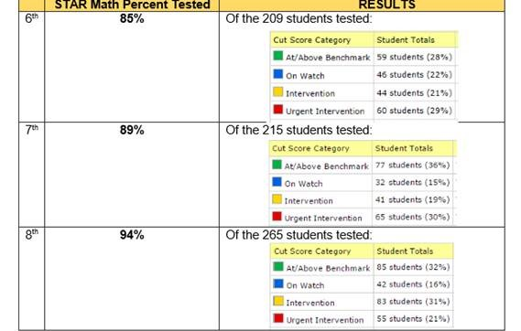
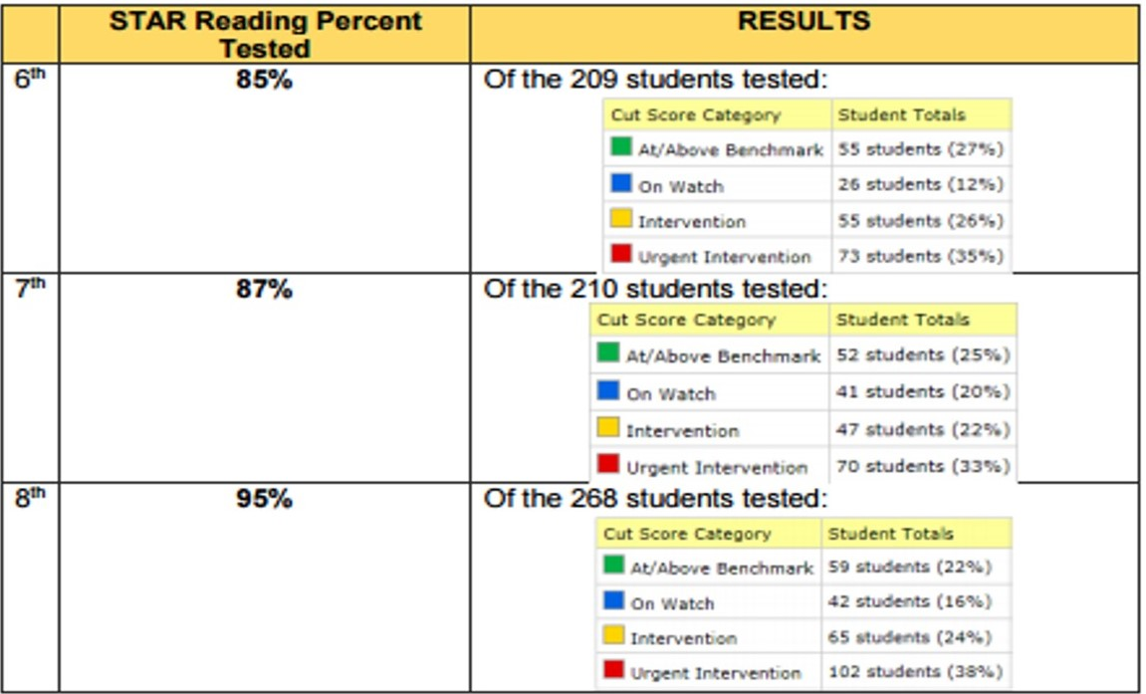
- Increase the Student Attendance Rate to 100%
STAR Reading School-wide Test Results
August – September 2015
STAR Math School-wide Test Results
August – September 2015

Cedar Grove Middle School will utilize a universal screener in reading and mathematics to assess current skills
and potential areas of improvement.

To help your child meet the district and school goals, the school, you, and your child will work together to:

School Responsibilities:

Cedar Grove Middle School, will:

- Provide high quality curriculum and instruction in a supportive and effective learning environment that enables the participating children to meet the state’s student academic achievement standards by:

Give universal screener to all students | Provide professional learning to staff
Provide additional academic support within the school day by providing additional Math Tools Class | Provide additional resources for core content areas
Maintain highly qualified staff

- Hold parent-teacher conferences during which this compact will be discussed as it relates to the individual child’s achievement.

Hold Annual Title I meeting invite all parents | Hold Curriculum/Core Content Nights
Review Title I School-Parent Compact throughout the year with all parents, students and teachers | Meet with parent conferences twice a semester
Hold additional Title I parent meetings | Review student data

The School-Parent Compact will be utilized as a tool during meetings and conferences to discuss strategies for improved academic classroom student performance. The compact will be utilized during both first semester conferences and the first conference of second semester and upon parent request.

- Provide parents with frequent reports on their children’s progress.

Utilize Parent Assistant / ePortal | Website http://www.cedargrovems.dekalb.k12.ga.us/
Progress Reports (every 4.5 weeks) | STAR Testing reports (Reports will be sent home (September 2015, February 2016, May 2016) or by Parent/Guardian Request
Provide opportunities for individual parent/teacher conferences through counseling center | Calling posts, flyers, other social media resources, marquee to announce reporting dates

- Provide parents reasonable access to staff.

Parents may request for teachers to adjust their schedules before and after school; however, teachers are available during their scheduled planning times for appointments. Teachers are also available during Curriculum Night, Title I meetings and scheduled conferences.

- Provide parents opportunities to volunteer and participate in their child’s class and to observe classroom activities as follows:
Volunteer opportunities for parents | Join PTSA and other school organizations
Participate in and observe class activities | Attend parent workshops and training
Attend school council meeting(s)/other parent meetings | See your Cedar Grove Middle Parent Liaison

Parent Responsibilities:

I/We, as (a) parent(s), will:

Keep student information current | Provide necessary supplies/ materials.
Provide a quiet study place at home | Maintain positive communication with teacher & school
Ensure students attend school/class daily | Attend trainings, meetings, workshops as scheduled
Read at home and discuss daily learning | Review progress reports with my child, teacher

Student Responsibilities:
I, as a student will:
Attend school daily | Bring necessary supplies/ materials
Complete homework and class work assignments | Maintain positive communication with teacher & school
Discuss academic performance with families | Take ownership of learning and performance
Read at home and discuss daily learning | Attend tutorials
Actively participate in the learning | Respect the learning process

Please review this School-Parent Compact with your child. This School-Parent Compact will be discussed with you throughout the year at different school-family events as we work together to help your child succeed in school.

Please sign and date below to acknowledge that you have read, received, and agree to this School-Parent Compact. Once signed, please return the form to your child’s teacher. We look forward to our school-parent partnership!

School Representative Signature: Date:

Parent/Guardian Signature: Date:

Student Signature: Date:

